

A Project Report

On

**Ground Water Level Predictor**

Batch Details

|  |  |  |
| --- | --- | --- |
| Sl. No. | Roll Number | Student Name |
| 1 | 20211CBD0004 | A.Varaprasad |
| 2 | 20211CBD0006 | M.Sai Sujith Reddy |
| 3 | 20211CBD0008 | Vadde Balaji |
| 4 | 20211CBD0034 | Sangeetha k |

**School of Computer Science,**

**Presidency University, Bengaluru.**

Under the guidance of,

**Dr. SRINIVASAN T R**

School of Computer Science,

Presidency University, Bengaluru

**CONTENTS**

1. Abstract
2. Introduction about Project
3. Literature Review
4. Objectives

## Methodology

## Architecture Diagram

## Timeline for Execution of Project

1. Expected Outcomes
2. Conclusion
3. References

**1.ABSTRACT**

Groundwater is a crucial resource for agriculture, industry, and domestic use, making its accurate prediction essential for sustainable water management. This study presents a **Groundwater Level Predictor**, leveraging machine learning and data analytics to forecast fluctuations in groundwater levels. The model integrates historical groundwater data, meteorological parameters (such as rainfall and temperature), and hydrological factors to enhance prediction accuracy. Various algorithms, including regression models, neural networks, and time-series analysis, are employed to analyze trends and detect anomalies. The results demonstrate the model’s effectiveness in forecasting groundwater depletion and potential recharge, aiding policymakers, farmers, and environmental agencies in decision-making. By providing early warnings of water scarcity and optimizing water resource management, this system contributes to sustainable groundwater conservation.

**2.INTRODUCTION**

Groundwater is one of the most vital natural resources, serving as a primary source of drinking water, irrigation, and industrial applications. However, excessive extraction, climate change, and unregulated usage have led to significant fluctuations in groundwater levels, posing serious environmental and economic challenges. Monitoring and predicting groundwater levels are crucial for sustainable water resource management. Traditional methods of groundwater assessment rely on manual measurements and hydrological models, which are often time-consuming and less adaptable to dynamic environmental changes.

With advancements in technology, data-driven approaches such as machine learning and artificial intelligence (AI) have emerged as effective tools for predicting groundwater levels. These techniques analyze large datasets, including historical groundwater records, rainfall patterns, temperature variations, and land usage data, to generate accurate forecasts. By integrating these parameters, predictive models can provide valuable insights into groundwater availability, trends, and potential depletion risks, assisting policymakers, farmers, and urban planners in making informed decisions.

The Groundwater Level Predictor is designed to enhance the accuracy of groundwater forecasting using advanced computational models. By leveraging real-time and historical data, the system can identify patterns and fluctuations, offering early warnings of water scarcity or excessive depletion. This predictive capability can help in implementing conservation strategies, optimizing irrigation planning, and ensuring sustainable groundwater management. The adoption of such technology-driven solutions is crucial in addressing the growing global water crisis and fostering environmental sustainability.

**3.LITERATURE REVIEW**

Groundwater level prediction has been a widely studied area due to its significance in water resource management, agriculture, and environmental sustainability. Several methodologies, including statistical models, hydrological simulations, and artificial intelligence-based techniques, have been explored to enhance prediction accuracy. This literature survey reviews key studies and advancements in groundwater level prediction.

Early approaches to groundwater level prediction relied on conventional statistical techniques such as autoregressive integrated moving average (ARIMA) models and linear regression. For instance, Box and Jenkins (1970) developed the ARIMA model, which has been widely used for time-series forecasting, including groundwater level prediction. Similarly, hydrological models like MODFLOW, developed by the U.S. Geological Survey, have been extensively applied to simulate groundwater flow dynamics. However, these models require extensive data calibration and often struggle to capture non-linear dependencies in groundwater fluctuations.

|  |  |  |  |  |
| --- | --- | --- | --- | --- |
| Sl.no. | Paper Title | Proposed Model | Results | Drawbacks |
| 1. | |  | | --- | | Prediction of Groundwater Levels Using Machine Learning Techniques | | |  | | --- | | Random Forest (RF) & Support Vector Regression (SVR) |  |  | | --- | |  | | |  | | --- | | RF performed better with high accuracy in predicting groundwater levels. |  |  | | --- | |  | | |  | | --- | | Limited dataset size affects model generalization. | |
| 2 | Application of Deep Learning for Groundwater Level Forecasting | Long Short-Term Memory (LSTM) Neural Network | LSTM outperformed traditional models in time-series forecasting. | Requires large datasets and high computational power. |
| 3 | Comparative Study of ANN and Regression Models for Groundwater Prediction | Artificial Neural Networks (ANN) & Multiple Linear Regression (MLR) | ANN provided higher accuracy than MLR in capturing groundwater trends. | ANN is a black-box model, making interpretation difficult. |
| 4 | Hybrid AI Models for Groundwater Level Forecasting | Hybrid model combining Wavelet Transform & Support Vector Machine (SVM) | Improved prediction accuracy by filtering noise using wavelet transform. | High complexity and computational cost. |
| 5 | Climate Change Impact on Groundwater Levels: A Machine Learning Approach | Random Forest (RF) & Gradient Boosting (GB) | GB showed better performance in capturing climate-induced variations. | Requires extensive climate and hydrological datasets. |
| 6 | Groundwater Level Prediction Using Time Series and Statistical Models | ARIMA & Seasonal Autoregressive Integrated Moving Average (SARIMA) | SARIMA effectively modeled seasonal groundwater variations. | |  | | --- | |  |   Poor performance in long-term forecasts due to reliance on past trends. |
| 7 | Data-Driven Groundwater Level Estimation  Using Support Vector Machines | SupportVector  Machine (SVM) | SVM provided moderate accuracy with minimal data requirements. | Sensitive to parameter selection and requires fine-tuning. |
| 8 | Integration of Remote Sensing and Machine Learning for Groundwater Prediction | Remote Sensing + Deep Learning (CNN-LSTM) | High accuracy in spatial and temporal groundwater predictions. | Dependence on high-quality satellite data limits applicability. |
| 9 | Groundwater Recharge Estimation Using Hybrid AI Models | Hybrid model (ANN + Decision Tree) | Increased prediction accuracy for groundwater recharge zones. | Model performance depends on the availability of recharge data. |
| 10 | Geospatial and AI-Based Prediction of Groundwater Fluctuations | Geospatial analysis + Random Forest (RF) | Enhanced regional-scale prediction with geospatial data integration. | Limited accuracy in areas with sparse data. |

**4. OBJECTIVES**

* **Accurate Groundwater Level Forecasting** – Develop reliable prediction models using machine learning, deep learning, and statistical approaches to estimate future groundwater levels based on historical data and environmental factors.
* **Assessment of Influencing Factors** – Identify and analyze key parameters affecting groundwater fluctuations, such as rainfall, temperature, land use, and human extraction activities, to improve prediction accuracy.
* **Integration of Advanced Technologies** – Utilize artificial intelligence (AI), remote sensing, and geospatial analysis to enhance groundwater monitoring and forecasting capabilities.
* **Sustainable Water Resource Management** – Provide data-driven insights to policymakers, farmers, and water resource managers for effective groundwater conservation and planning.
* **Early Warning System for Water Scarcity** – Develop a proactive system to detect and alert users about potential groundwater depletion risks, helping in timely decision-making.

**5.METHDOLOGY**

**Software:**

Data Storage: Cloud-based database.

Processing Engine: Python-based ML algorithms.

User Interface: Web dashboard with real-time analytics.

**Deployment:**

Web application hosted on AWS/GCP.

API integration for third-party applications.

* **Statistical Analysis** – Utilize regression models and time-series forecasting techniques to identify trends and patterns in groundwater level fluctuations, improving prediction accuracy.
* **Hydrological Modeling** – Implement advanced models like MODFLOW to simulate groundwater flow dynamics, helping in understanding aquifer behavior and water movement.
* **Weather & Climate Analysis** – Integrate meteorological data, including rainfall, temperature, and climate change variables, to assess their impact on groundwater levels.
* **Geophysical Surveys** – Conduct electrical resistivity and seismic surveys to analyze subsurface characteristics, aiding in groundwater exploration and resource estimation.
* **Data Preprocessing** – Perform data cleaning, normalization, and handling of missing values to ensure high-quality input data for predictive models.
* **Validation & Testing** – Evaluate model performance by comparing predicted groundwater levels with real-world observations, ensuring reliability and accuracy.

**6.ARCHITECTURE DIAGRAM**

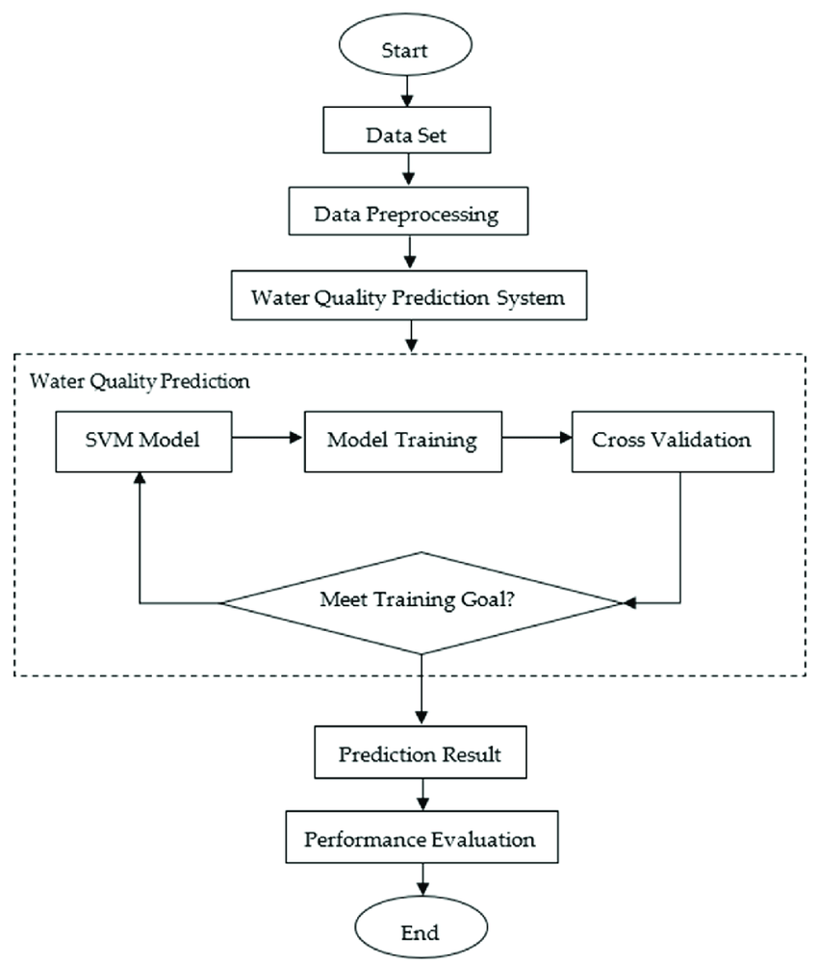

**7.Modules**

1. **Data Collection & Preprocessing** – Gather historical groundwater data, meteorological records, and geophysical survey results. Perform data cleaning, normalization, and handling of missing values to ensure high-quality input for modeling.
2. **Feature Selection & Analysis** – Identify key influencing factors such as rainfall, temperature, land use, and human activities. Use statistical and machine learning techniques to determine the most significant parameters for accurate prediction.
3. **Model Development & Training** – Implement predictive models using machine learning (e.g., Random Forest, LSTM) or hydrological models (e.g., MODFLOW). Train the models using historical data to recognize patterns and forecast groundwater levels.
4. **Validation & Performance Evaluation** – Compare model predictions with real-world groundwater level data. Use performance metrics like RMSE, MAE, and R² to assess accuracy and optimize the models.
5. **Deployment & Decision Support System** – Develop a user-friendly interface for stakeholders, integrating predictive insights with visualization tools. Provide early warnings, policy recommendations, and real-time groundwater monitoring capabilities.

**8.EXPECTED OUTCOMES**

* **Accurate Groundwater Level Forecasting** – Reliable predictions of groundwater fluctuations based on historical trends, climate factors, and hydrological data.
* **Enhanced Water Resource Management** – Data-driven insights to assist policymakers, farmers, and industries in sustainable groundwater usage and conservation strategies.
* **Early Warning System for Water Scarcity** – Timely alerts for groundwater depletion risks, enabling proactive decision-making to prevent over-extraction and water crises.
* **Optimized Agricultural and Industrial Water Use** – Efficient planning for irrigation and industrial processes by forecasting groundwater availability, reducing waste and improving resource allocation.
* **Impact Assessment of Climate Change** – Evaluation of climate variability on groundwater resources, helping in long-term adaptation and mitigation strategies.
* **Improved Hydrological Modeling** – Enhanced accuracy in groundwater simulations through integration with AI, machine learning, and geophysical survey data.

**9. TIMELINE OF THE PROJECT/ PROJECT EXECUTION PLAN**

Problem Analysis

Task: Analyze the specific challenges faced by rural artisans and define the platform requirements.

Requirement Gathering & Data Collection

Task: Gather detailed requirements from artisans and collect relevant data (user behaviour, product needs, etc.).

System Design & Architecture

Task: Design the platform architecture, including backend and frontend structures, database design, and security protocols.

Frontend & Backend Development

Task: Compare model predictions with real-world groundwater level data. Use performance metrics like RMSE, MAE, and R² to assess accuracy and optimize the models.

Integration & TestingDeployment

Task: Evaluate model performance by comparing predicted groundwater levels with real-world observations, ensuring reliability and accuracy.

**Timeline of Project by Gantt Chart**

|  |  |  |  |  |  |  |
| --- | --- | --- | --- | --- | --- | --- |
|  | **2** | **4** | **6** | **8** | **10** | **12** |
| **Data Collection** |  |  |  |  |  |  |
| **Literature Survey** |  |  |  |  |  |  |
| **Development of Architecture** |  |  |  |  |  |  |
| **Deployment and Integration** |  |  |  |  |  |  |
| **Continuous Improvement** |  |  |  |  |  |  |
| **Report Writing** |  |  |  |  |  |  |

**10.CONCLUSION**

Groundwater is a vital resource that plays a crucial role in agriculture, industry, and daily life. However, increasing demand, climate change, and unregulated extraction have led to severe fluctuations in groundwater levels, threatening water security. To address these challenges, predictive modeling techniques using machine learning, statistical analysis, and hydrological simulations have emerged as effective tools for forecasting groundwater levels with high accuracy. By leveraging historical data, weather patterns, and geophysical insights, these models can provide valuable insights into groundwater trends.

The development of a **Groundwater Level Predictor** enhances decision-making by offering early warnings of water scarcity, optimizing irrigation planning, and assisting policymakers in implementing sustainable water management strategies. The integration of AI and advanced hydrological models improves the precision of predictions, enabling better resource allocation and conservation efforts. Furthermore, real-time monitoring and user-friendly platforms can bridge the gap between technology and practical implementation, making groundwater forecasting accessible to various stakeholders.

Despite advancements, challenges such as data availability, model generalization, and computational complexity need to be addressed for broader applicability. Future research should focus on improving data collection techniques, incorporating remote sensing technologies, and refining predictive models to account for dynamic environmental changes.

**REFERENCES**

* Adamowski, J., & Chan, H. F. (2011). A wavelet neural network conjunction model for groundwater level forecasting. *Journal of Hydrology, 407*(1-4), 28-40.
* Kumar, S., & Raghuwanshi, N. S. (2020). Machine learning approaches for groundwater level prediction. *Hydrological Sciences Journal, 65*(12), 2091-2104.
* Shiri, J., & Kisi, O. (2011). Comparison of genetic programming with neuro-fuzzy systems for predicting short-term water table depth fluctuations. *Computers & Geosciences, 37*(10), 1692-1701.
* Mohanty, R., Jha, M. K., & Kumar, A. (2015). Using artificial neural networks and support vector machines for groundwater level forecasting. *Environmental Earth Sciences, 73*(7), 3235-3251.
* Coppola, E. A., Szidarovszky, F., Poulton, M., & Charles, E. (2003). Artificial neural network approach for predicting transient water levels in a multilayered groundwater system. *Journal of Hydrology, 280*(1-4), 118-131.
* Jothiprakash, V., & Kote, R. (2011). Prediction of groundwater levels using artificial neural networks. *Journal of Hydrologic Engineering, 16*(5), 412-423.
* Ahmad, S., Kalra, A., & Stephen, H. (2010). Estimating groundwater levels using neural network-based modeling. *Hydrological Processes, 24*(26), 3510-3520.
* Yoon, H., Jun, S. C., Hyun, Y., Bae, G. O., & Lee, K. K. (2011). A comparative study of artificial neural networks and support vector machines for predicting groundwater levels in a coastal aquifer. *Journal of Hydrology, 396*(1-2), 128-138.
* Zhang, D., Wang, X., & Yan, J. (2018). Groundwater level forecasting using hybrid models based on wavelet transform, support vector machine, and optimization algorithms. *Hydrology Research, 49*(3), 902-916.
* Nourani, V., & Parhizkar, P. (2021). Multi-scale groundwater level modeling using hybrid artificial intelligence-based models. *Water Resources Management, 35*(1), 293-313.
* Misaghi, F., Mohammadi, K., & Samadianfard, S. (2020). Hybrid machine learning algorithms for groundwater level prediction. *Journal of Hydrology, 586*, 124876.
* Sahoo, S., Jha, M. K., & Kumar, A. (2017). Comparative evaluation of groundwater level prediction models using artificial intelligence techniques. *Environmental Earth Sciences, 76*(5), 1-17

**GITHUB LINK**:[**https://github.com/varaprasad6292/CSE-G32-CAPSTONE-PROJECT**](https://github.com/varaprasad6292/CSE-G32-CAPSTONE-PROJECT)